**COMSATS University, Islamabad**

**Project**

**Title: Flight Ticketing System**



**Subject: Introduction to ICT (Lab)**

**Submitted To:**

Ms. Hina Jamil

**Group No. 4**

**Group Leader:**

Muhammad Abdullah

SP20-BSE-074

**Group Member:**

Fatima Attique

SP20-BSE-080

**10 August 2020**

**Department of Computer Science**

**Wah Campus**

Flight Ticketing system

# Introduction

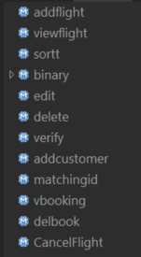Our project based upon a management system of flights which have many feature’s such as ticketing system, edit record, delete record, user define bubble sorting, binary search, cancelation of flight by customer, unique booking id and unique flight No. etc. all these feature will be explained below in details

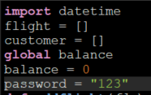We have used library of datetime in the very beginning of code to make our project works efficiently

In beginning we declare two lists named as (flight and customer), and set a password for admin staff through which they can access their accounts and a variable named as balance

Our project is based upon user defined function’s and list’s

Our project has two phases: -

1. Admin view
2. Customer view

# Explanation about project in detail

We use main while loops used for Repeating of Menu and inside, we use exception loop (try and except) while taking input.

it has main menu which show the following option

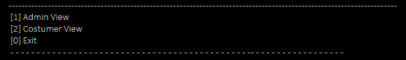**1**. Admin view

**2.** Customer view

**0.** Exit

If the user press [1] it goes to admin view or the user press [2] then in customer view and if the user press [0] Program Exit. Otherwise the program show, please Enter the given option only

The main menu has further 2 sub-menu one is for admin view and other is for customer view

## Admin view

First, our program asks for password that is set for the staff if the password is correct then the program execute further

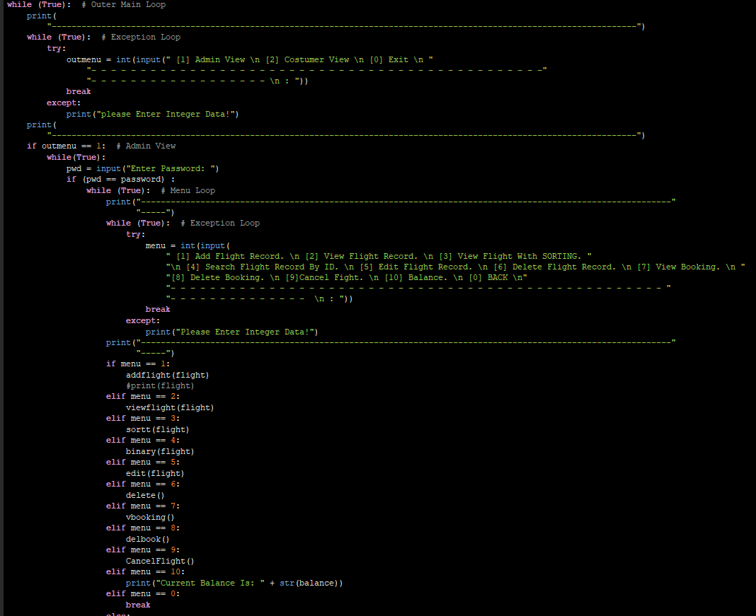

In admin view all the function that we defined for staff are called in simple if-else statements following are the option in admin view: -

1. [1] Add Flight Record.
2. [2] View Flight Record.
3. [3] View Flight With SORTING.
4. 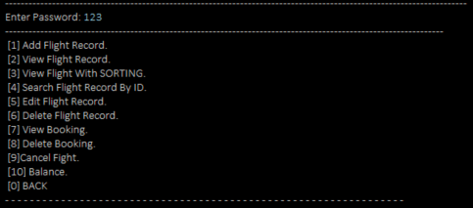[4] Search Flight Record by ID.
5. [5] Edit Flight Record.
6. [6] Delete Flight Record.
7. [7] View Booking.
8. [8] Delete Booking.
9. [9] Cancel Fight.
10. [10] Balance.
11. [0] BACK

If the user enters any of the following numbers, then the function on that number will be executed.

### Add flight record

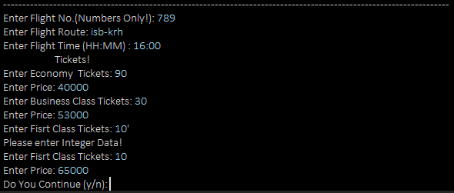 **How this function works**

*When this function execute it ask the staff member to enter the flight number (which would be unique) and then to enter the route of flight (from to where ), then ask for timing of flight which will be in (HH:MM) format e.g. 17:00, and the enter the record of tickets in plane and there prices following are the types of tickets (economy, business, first-class).*

**Explanation of code**

The name of this function is addflight(flg) having 1 parameters on calling we pass main list(flight) as an argument ,we use main while loop for repeating the function and 2nd while loop is for unique id in which we input the flight id in exception loop and check either the flight id that user is entering is existing or not if it is existing then show the result please enter unique id otherwise it append the value in main list,

the 2nd thing is the route of flight I use input statement to enter the flight route and then append in main list.

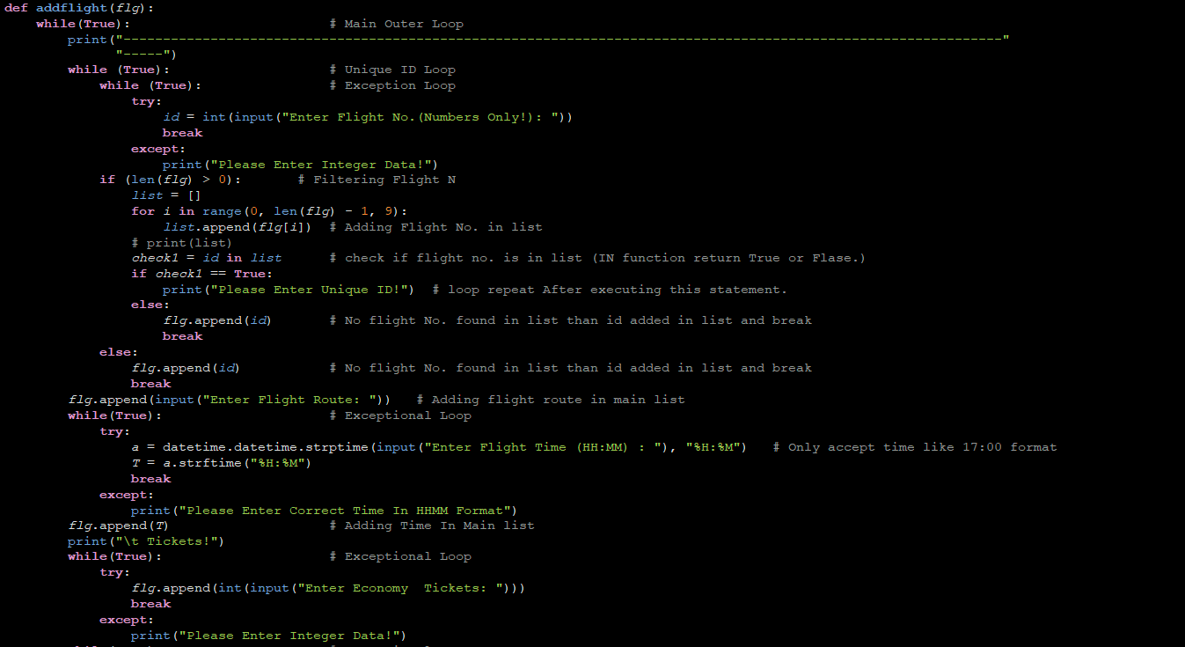3rd thing is the timing as I had imported the library of datetime, so we used in this feature that helps to make a format of time i.e. **HH: MM.**

Now the record of tickets began,

4th In exception loop we use input statement to enter the total number of economy seats and append it in main list(**flight**).

5th In exception loop we use input statement to enter the total price of economy seats and append it in main list(**flight**).

6th In exception loop we use input statement to enter the total number of business seats and append it in main list(**flight**).

7th In exception loop we use input statement to enter the total price of economy seats and append it in main list(**flight**).

8th In exception loop we use input statement to enter the total number of first-class seats and append it in main list(**flight**).

9th In exception loop we use input statement to enter the total price of economy seats and append it in main list(**flight**).

Then through while loop we gave an option to re-enter data or not.

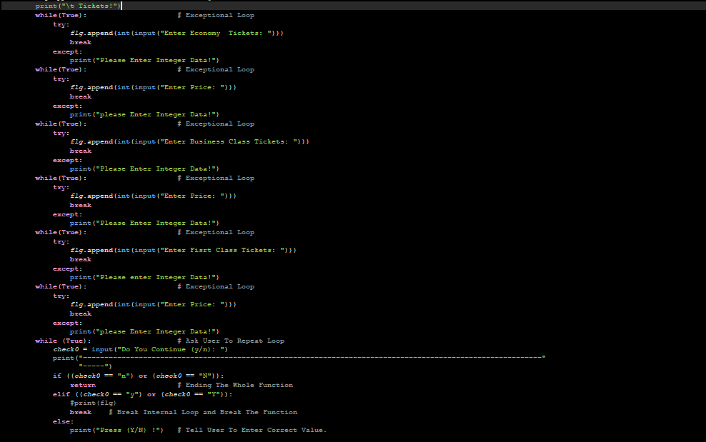

### View Flight Record

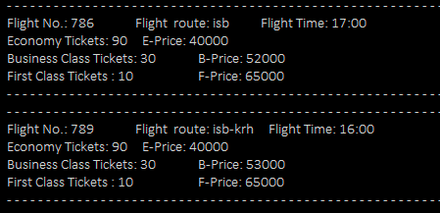**How this function works**

*When this function executed it show all the record enter by the staff (flight id, timing, tickets, and prices etc.) in proper format.*

**Explanation of code**

Its function is named as viewflight(flg) and on calling we pass as argument, main list (**flight**). Then we check either any record exist if not then it show the result please enter the record .otherwise ,we use a for loop to get the value of flight id and through proper concatenation we made a full table of all the record which is in enter in the list of flight

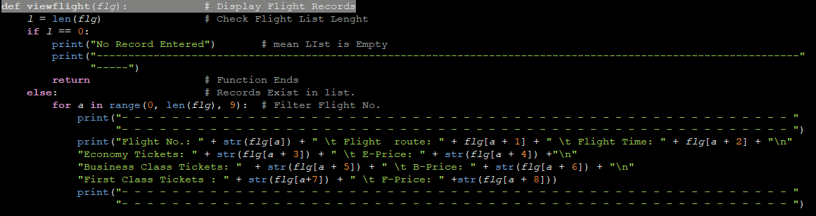

### View Flight With SORTING.

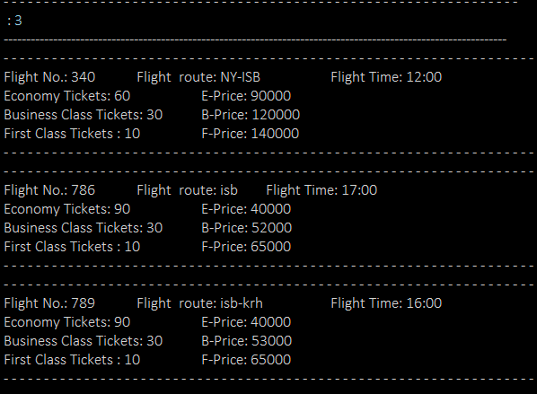**How this function works**

*When this function executed it show all the sorted record added by the staff, we have sorted the record by flight number*

**Explanation of code**

we use a mechanism of bubble sort in this user defined sorting the name of the function is **sortt(num)** when we call the function we pass the main list(flight) as argument, we use two for loop one is main having “**i**” variable and the other one is nested for loop having “**j**” variable the first loop store value of flight No. in **“i”** in reverse direction by jumping of 9 and nested loop run from 0 to **“i”** with jumping of 9

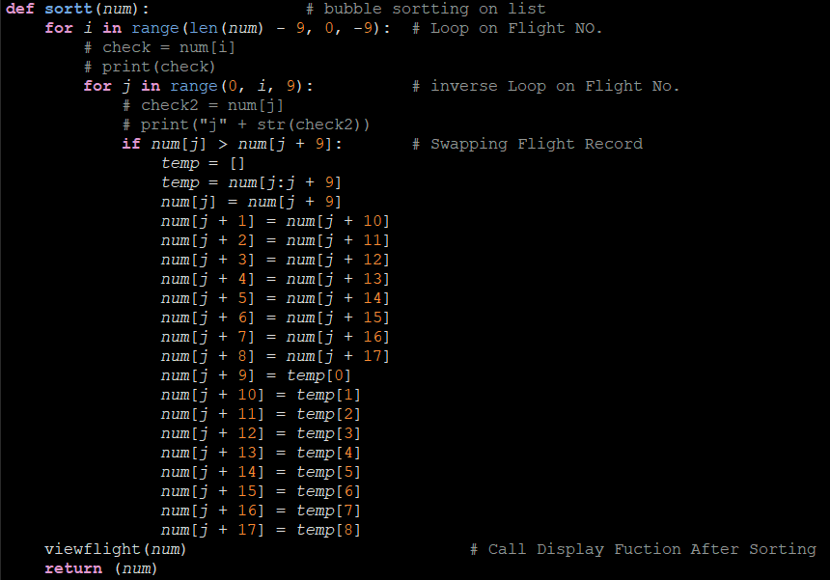The we implement a condition of **j > j+9** then store the value in a temporary list and store the value in it and did swapping and at last return a sorted list

### Search Flight Record By ID

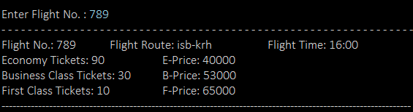**How this function works**

*When this function executed it ask staff member to enter the flight number you want to search if the flight number is existing then it show the record as showed in (view flight record ) , if the flight number is not existing in the list then it show flight number does not exist*

**Explanation of code**

we use the mechanism of binary search in this function on flight id in main list(**flight**)

First, we sort the list then

Then we check either the list is empty or not, we make a temporary list in which we append the flight No. using for loop with jumping of 9 after this I made a sub function named as **search1(list, n),** in which initially we gave a value of index as **-1** which will overwrite below and then gave a value of lower value as **“l”** (variable) and upper value as (**u**) and then find the mid of **l** and **u** by integral division and then apply some condition

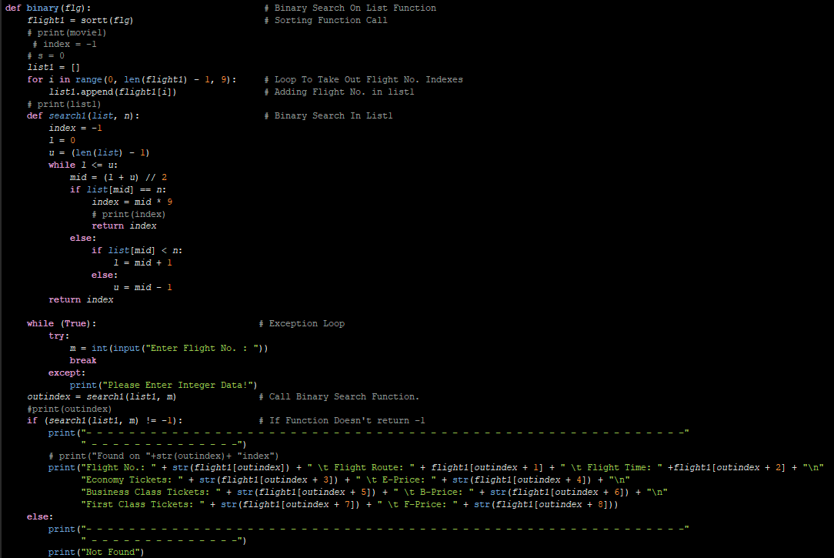When this sub-function end’s, by proper concatenation we print the whole format of repetitive flight No.

### **Edit Flight Record**

**How this function works**

*This function is used by the staff to edit the record that they entered in (add flight record)*

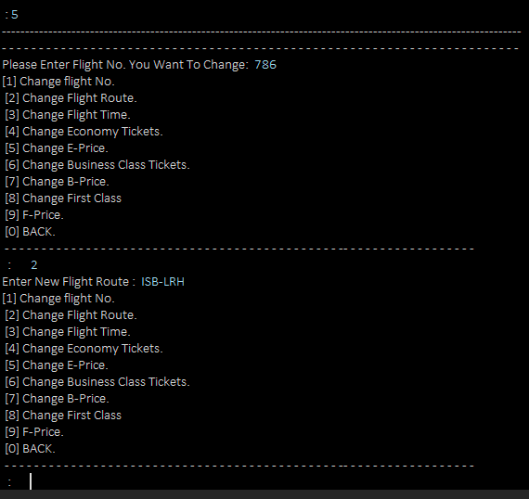*First, it asks to enter the flight No. to make sure in which flight number they want to edit the record and its show the menu*

* [1] Change flight No.
* [2] Change Flight Route.
* [3] Change Flight Time.
* [4] Change Economy Tickets.
* [5] Change E-Price.
* [6] Change Business Class Tickets.
* [7] Change B-Price.
* [8] Change First Class
* [9] F-Price.
* [0] BACK.

*And then it up to the staff that in which thing they want to make change just enter the number*

*And enter the new value*

**Explanation of code**

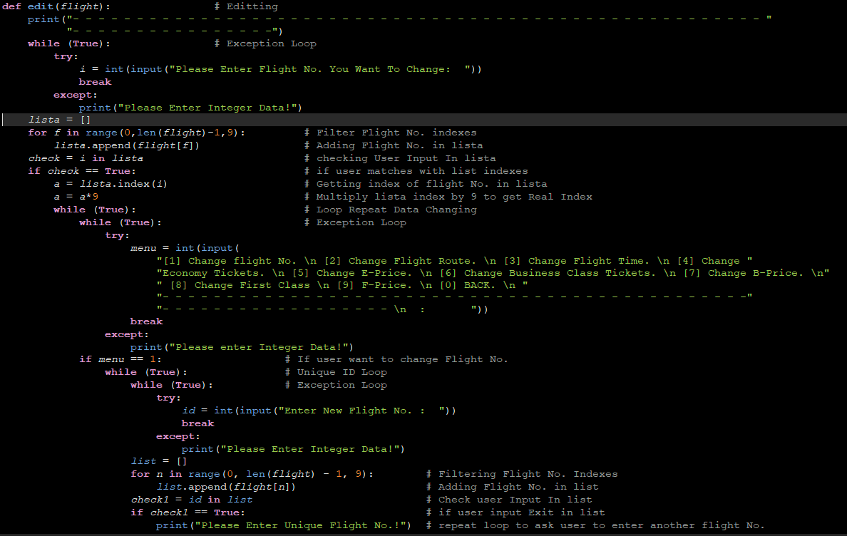The name of the function is edit(flight) on calling we passed main list (**flight**) as argument first we input a flight No. that admin want to change then we make a temporary list in which we append all the flight No.’s using for loop by the jumping of 9 then check the entered flight No. in this list if the flight exist in the list then its show the whole menu

If we can change anything from that menu the new value will overwrite the previous value

After editing I used a while loop that gave an option to rechange the value by pressing [y\n]

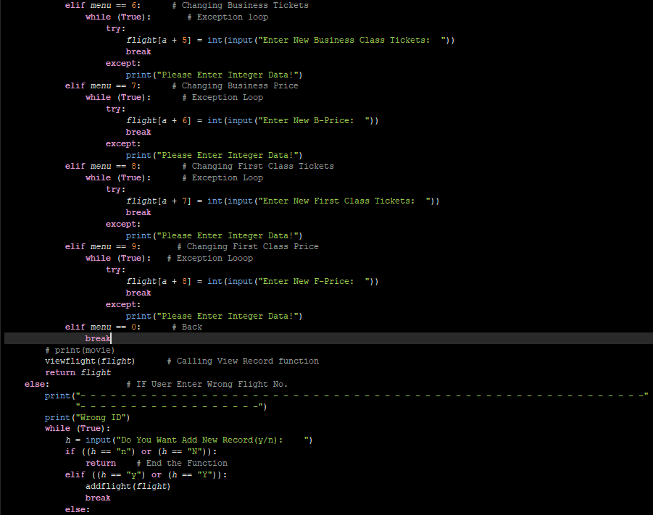

### Delete Flight Record.

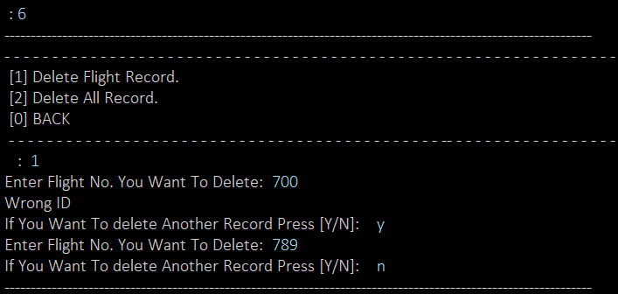**How this function works**

*This function is used by staff to delete any flight record that was entered by staff in (add record) when this function execute it give further three options:*

* [1] Delete Flight Record.
* [2] Delete All Records.
* [0] BACK

*If staff member press 1 then program ask for enter flight No. then the corresponding record will be deleted, if staff member press 2 then all the record of flights and Bookings will be deleted, if 0 then the program directly goes to admin view*

**Explanation of code**

In this function we use main while loop for repeating menu, then we make a small menu

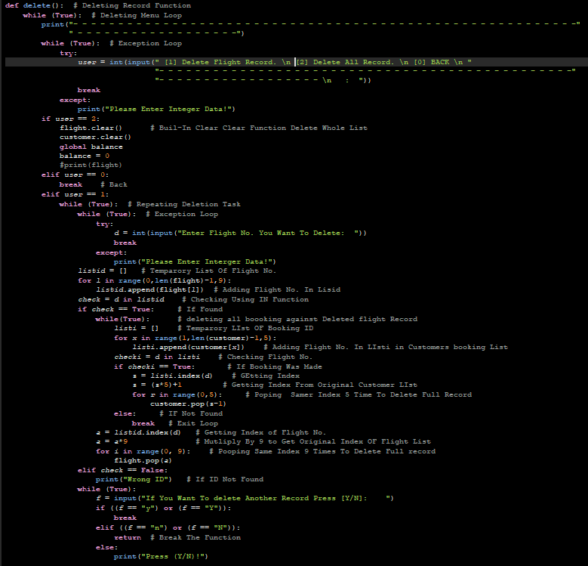If 1 first off all we ask to enter flight No. you want to delete in exception loop, then we make a temporary list in which all the flight No.’s have appended through for loop with jumping of 9 and then checked the entered flight No. in it and then we delete all the record on the corresponding flight No. using for loop and delete all the bookings on this flight too , *balance will also be deducted*

if the admin presses 2 then the all the value in the main list(**flight**) will be deleted we used **clear ()** built in function

if press 0 then the main loop breaks

### View Booking.

**How this function works**

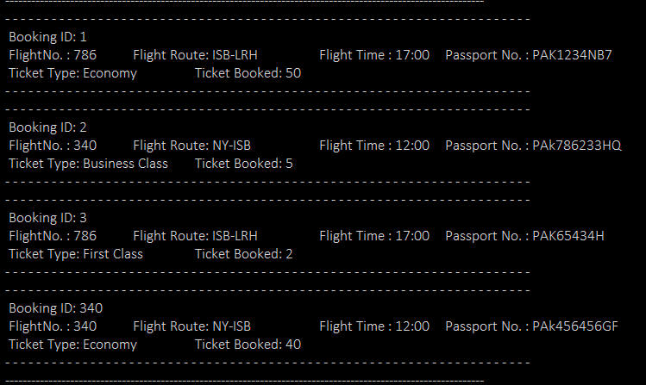*This function is used to view the booking of customer that are booked, it shows the full detail of customer its passport number, ticket type (economy, business etc.) and number of seats booked*

**Explanation of code**

First , we check whether there any record in customer if have then continue, if there is not any record in customer list then statement of (*please enter the booking*) will be show to customer, and in else statement we filter the booking id from customer list by jumping of 5 using for loop and store its index in (**i**) then we use another for loop to filter the flight No. from flight list by jumping of 9 using for loop and store its index in a temporary list named as **list2**, we gather the index of flight No. from **list2** and multiply it with 9 and then through proper concatenation we print the full table of record

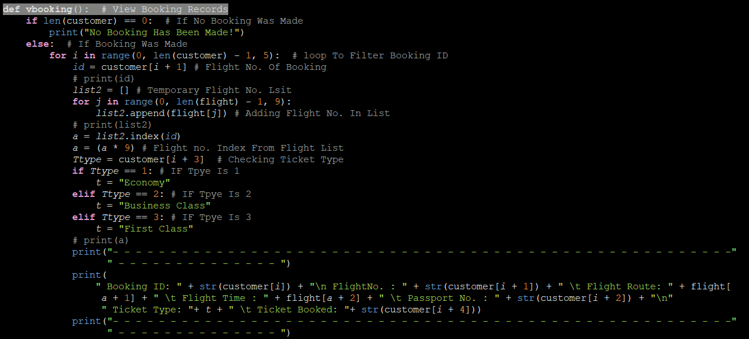

### Delete Booking

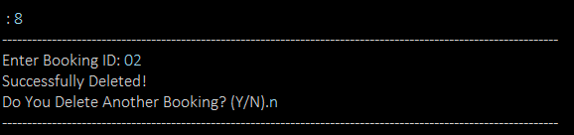**How this function works**

*The booking which are done by customer are deleted by this function what user need to do is just enter the booking id then the booking will be deleted*

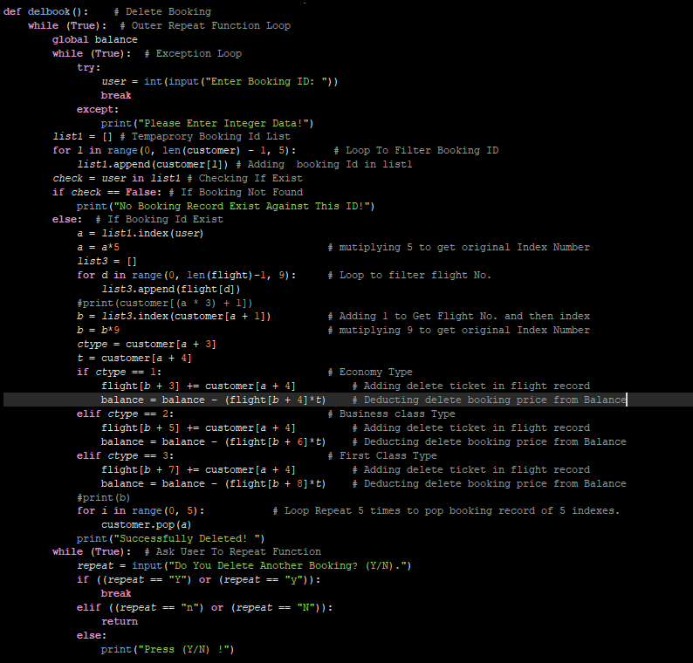

**Explanation of code**

First, we ask to enter booking ID you want to delete in exception loop, then we make a temporary list in which the all the booking IDs have appended through for loop with jumping of 5 and then checked the entered booking id in it and then we delete all the record on the corresponding booking ID using for loop and add those tickets again in flight record list , balance will also be deducted

at last I gave an option to re delete booking using while loop

### Cancel Fight.

**How this function works**

*This function is used to cancel the flight that was enter by the staff in (add record), by this function the record of flight No. not deleted but its status will have changed to cancelled. And Booking Will be Deleted*

**Explanation of code**

The name of the function is **Cancelflight (),** first of all we check either any record is entered in the main list or not, then through input statement in exception loop we entered the flight No., then we made a temporary list in which we append all the flight No. from the main list (**flight**) using for loop by the jumping of 9 and checked the entered flight No. in it the we use nested while loop in which we make another temporary list and append all the flight No. from the list of (customer) because it is possible that the customer have booked seats on this flight, using for loop by jumping of 5 and match flight No. in this list after this we deducted the balance if the customer booked any type of seats then balance will be deducted respectively

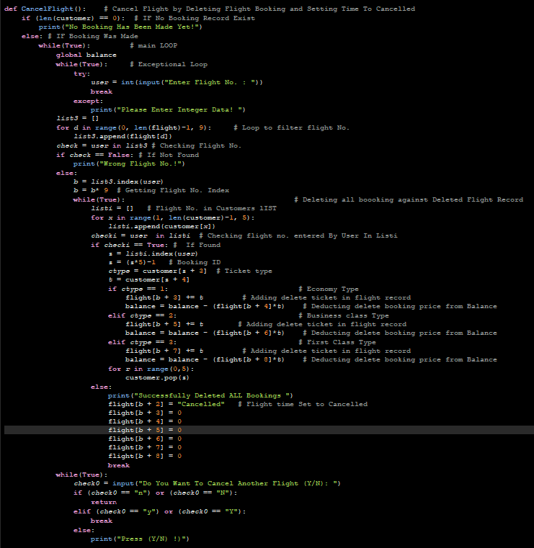

### Balance.

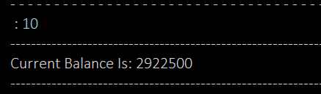**How this feature works**

*This function act as a small account that have all the record of total price of tickets that had booked by the customer*

**Explanation of code**

The value of balance was returned from a function addcustomer (booking, flg) when the customer book his seat then the balance will have updated automatically

### 0. Back

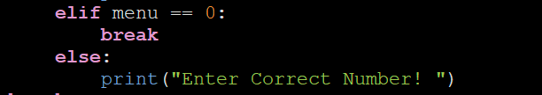In this option we used the command of break that break the nested while loop and the program moves one step backwards

## Customer view

Customer view is for customer from where they can see the available flights, or they can book their flight and can see there booking as well following are the features of customer view: -

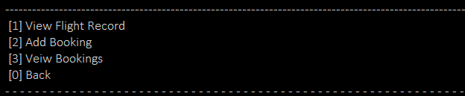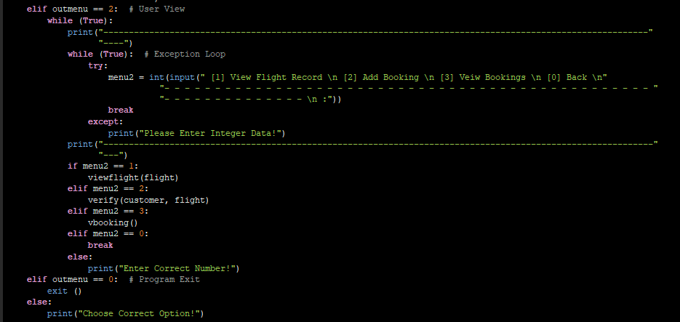

* [1] View Flight Record
* [2] Add Booking
* [3] View Bookings
* [0] Back

The customer must press the corresponding number to open the function

### View Flight Record

**How this function works**

*When this function executed it show all the record enter by the staff (flight id, timing, tickets and there prices etc.) in proper format*

**Explanation of code**

Its function is named as **viewflight (flg)** and on calling we pass as argument, main list (**flight**). Then we check either any record exist if not then it show the result please enter the record .otherwise ,we use a for loop to get the value of flight No. and through proper concatenation we made a full table of all the record which is in enter in the list of flight 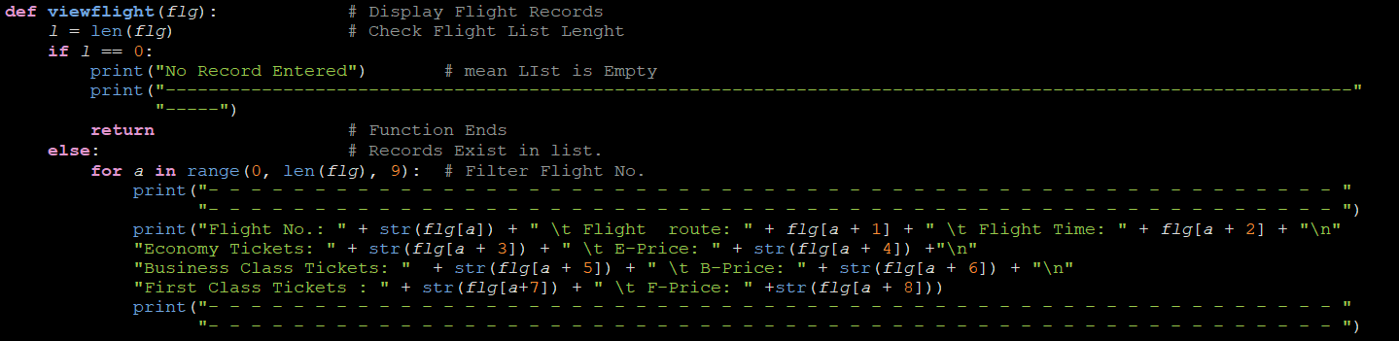

### Add Booking

**How this function works**

*Through this function the customer easily booked their ticket by providing their passport number, and their specific booking ID, the total price of tickets that are entered by the admin also shown in this function*

**Explanation of code**

Three functions are used to make this feature their names are

* Verify (customer, flight)
* addcustomer (booking, flight)
* matching id ()

**verify ()** is the main booking function, **addcustomer ()** is called in verify function and **matchingid ()** is called in **addcustomer ()**

**Verify Function**

We use two while loop 1 is for repeating Function and to give option that you want to repeat the function and the other is for repeating incase if record is incomplete, we make a temporary list named as booking and called **addcustomer (booking, flight).** And then all the record will be appended in main list (**customer**)

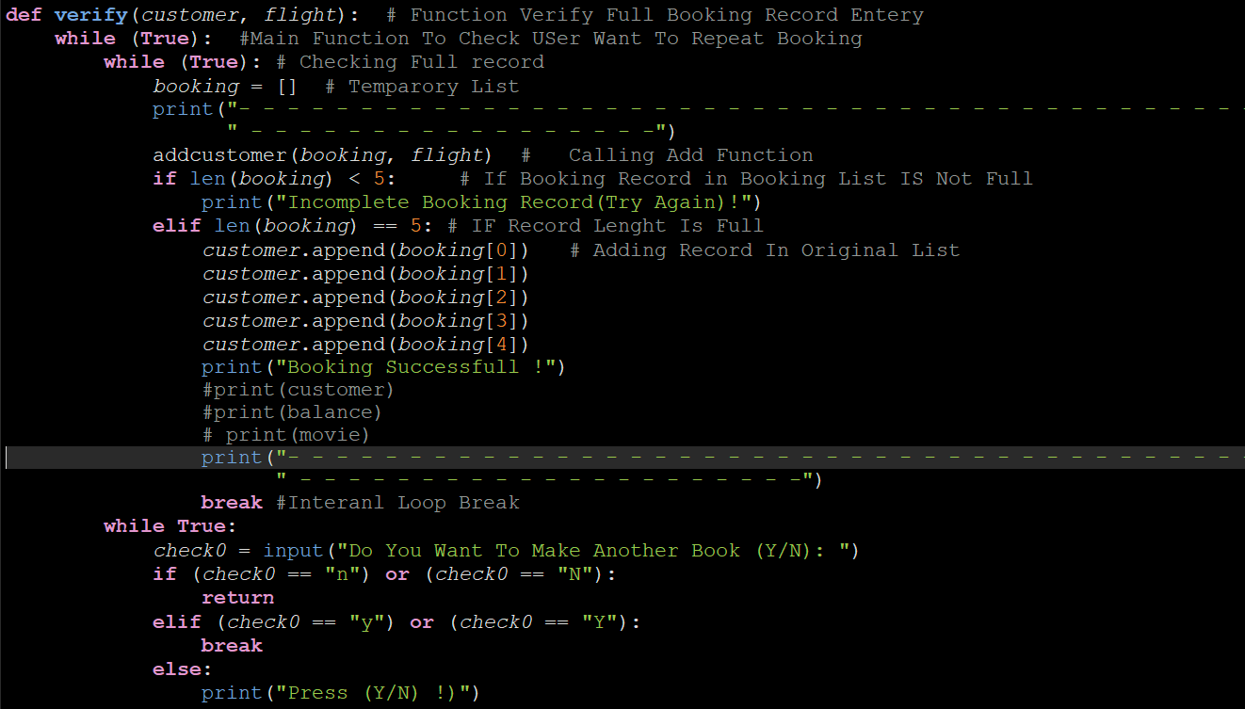

**Addcustomer Function**

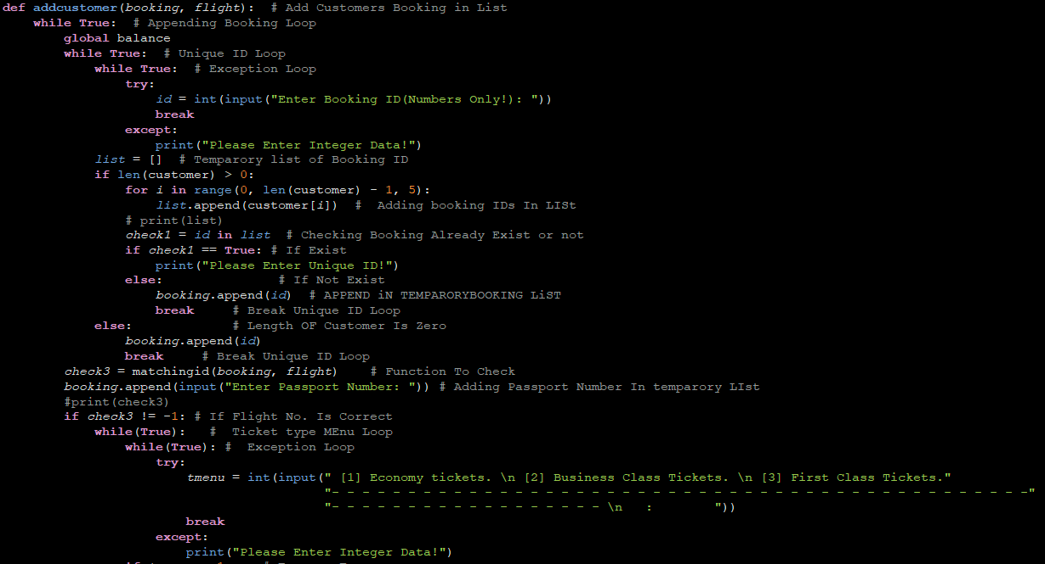We Use the parameter of customer and flight both are list on function calling we use main while loop(Unique ID), and make the variable of balance global then we use exception loop and make a temporary list in which we append all the booking IDs and Check whether user enter unique ID or Not. And Then After Matchingid Function and Appending Password No. in Temporary Booking List we provide menu which give option of economy, business, and first-class seats there prices and there total amount will be return from balance and its value stored in global Balance Variable which will be seen in admin view

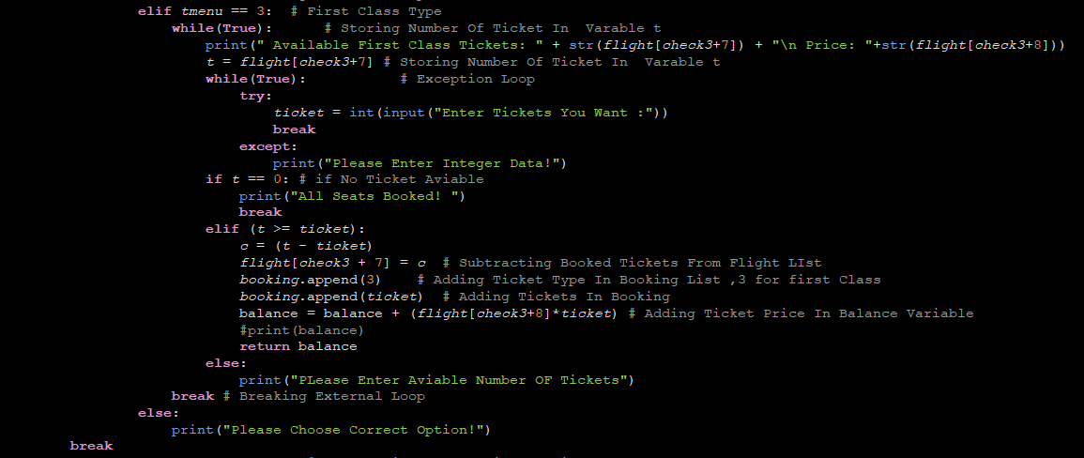

**Matchingid Function**

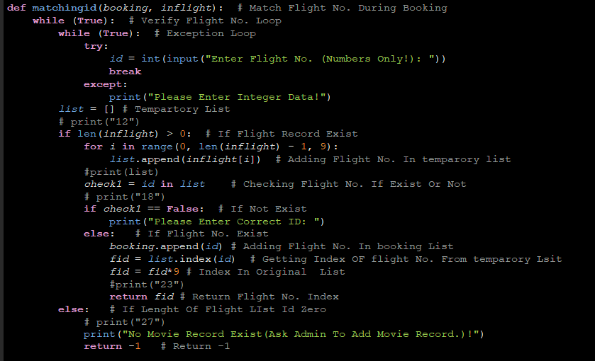The purpose of this function to check the flight No. in main list(**flight**) we use main while loop to check either the flight No. exist or not mean (User should Enter Correct Flight No. otherwise it will ask user to enter correct flight No.)then we used another while loop for exception and then make a temporary list and append all flight No. in this list using for loop by jumping of 9 and check the flight No. in this list if it is in list then its return the flight No. with index and further proceeds else it show Fight No. not found and it outer else its show please enter Correct Flight No.

### View Bookings

**How this function works**

*By this function customer can saw there booking that are booked in (****customer****), In proper format all the information of customer passport number, number of ticket’s booked, type of seat etc.*

**Explanation of code**

First of all we check whether there any record in customer if have then continue, if there is not any record in customer list then statement of (please Add the booking) will be sown to customer, and in else statement we filter the booking id from customer list by jumping of 5 using for loop and store its index in (**i**) then we use another for loop to filter the flight No. from flight list by jumping of 9 using for loop and store its index in a temporary list named as **list2**, we gather the index of flight No. from **list2** and multiply it with 9 and then through proper concatenation I print the full table of record

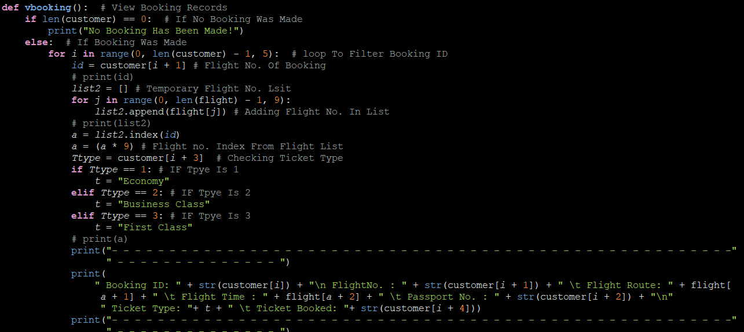

### Back

In this option we used the command of break that escape the nested while loop and the program moves one step backwards.